6. The Strait of Gibraltar
Notes for the teacher
- This Worksheet begins with tasks aiming to familiarize students with English terminology connected to geoscience and provides practice in understanding written texts of this kind and extracting information from them. That is why the first tasks are done individually.
- The teacher hands out to students photocopies of Worksheet 2 and before the students begin working on their own, the teacher should make sure they know the needed vocabulary, such as “located”, “bordered”.
- Task 3 is done in pairs or small groups of 4 or 5 students, so that they can negotiate the answers and reach conclusions.
Duration: 60 minutes
Necessary material:
- Photocopies of the Worksheets
- Dictionaries (on line and hard copies)
- Access to the Internet
- Geography books
- World map and a globe

Worksheet 1: The Geography of the strait of Gibraltar
Grouping: (individual)
- On the following link, you can find maps of the Strait of Gibraltar and the wider area: http://www.worldatlas.com/aatlas/infopage/gibraltar.htm
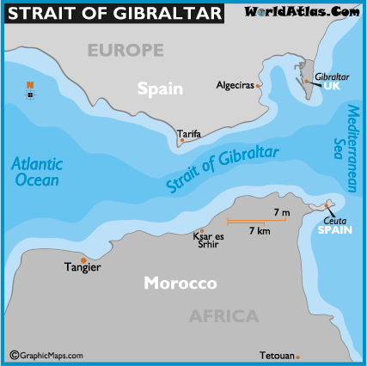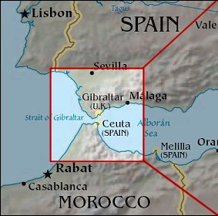
- Find a map of the Straight of Gibraltar in the above address or use another map to answer the following questions (Circle or underline the correct one/ones):
  - The strait of Gibraltar is located in
    - Southern Europe / Northern Africa
    - Northern Europe / Southern Africa
  - The strait of Gibraltar connects
    - an ocean to a sea
    - two oceans
    - two seas

  - The strait of Gibraltar is bordered by
    - Morocco
    - Spain
    - Gibraltar
    - Ceuta (a Spanish autonomous city)
    - France
    - Egypt
    - Portugal
  - The Strait of Gibraltar is located in the
    - Northern
    - Southern
    - Eastern
    - Western coast of Spain

Answer sheet for Worksheet 1
- The strait of Gibraltar is located in
  - Southern Europe / Northern Africa
- The strait of Gibraltar connects
  - an ocean to a sea
- The strait of Gibraltar is bordered by
  - Morocco
  - Spain
  - Gibraltar
  - Ceuta (a Spanish autonomous city)
- The Strait of Gibraltar is located in the
  - Southern coast of Spain

